ELEC1006
Professional Task – Phyphox

Task 1: Acceleration (without g) – Distance Calculation

Parameter | Value
Course | ELEC1006
Assessment | Professional Task
Task | Task 1 – Acceleration (without g)
Sensor | MEMS Accelerometer (Phyphox)
Programming Language | C++
Recording Duration | ~10 seconds (996 samples)
Input File | task1_acceleration_2.csv
Student Name | [Your Name]
Student ID | [XXXXXXXX]
Date | [Submission Date]

1. Introduction
This report is about collecting and analysing data from smartphone accelerometers for the ELEC1006 Professional Task. The experiment uses a smartphones built-in inertial measurement unit (IMU) to record acceleration data. This is done with the help of the Phyphox application. The report explains how real-world smartphone accelerometer data was collected and analysed.

It was part of the ELEC1006 Professional Task. The Phyphox mobile application was used to record acceleration data from the smartphones built-in IMU. The gravitational component was removed by Phyphox. The main goal of Task 1 is to process raw acceleration data to estimate the distance the device travelled during recording. The data is recorded along three axes: X, Y and Z. To do this we read a CSV file exported by Phyphox. Then we correct for sensor bias by subtracting the offset. After that we use numerical integration with the trapezoidal rule.

This converts acceleration into velocity and velocity into displacement and distance. The analysis is done in C++ using the standard library. The program can handle issues with Phyphox CSV exports, like rows and a special 5-column format. The results are printed to the terminal. Saved to a CSV file.

2. Method

2.1 Data Acquisition
Sensor data was recorded using the Phyphox application installed on a smartphone. The following procedure was followed:

- Open Phyphox and select the Acceleration (without g) experiment
- Tap Start and move the phone freely for approximately 10 seconds
- Tap Stop to end the recording
- Navigate to Actions → Export Data → CSV (comma-separated values)
- Transfer the exported CSV file to a computer
- Remove unnecessary columns, retaining only: Time (s), Linear Acceleration x, y, z (m/s²)
- Save the file as task1_acceleration_2.csv

The exported CSV file contained 996 valid data samples spanning approximately 10 seconds (t = 0.00748 s to t = 10.00 s), at a sample rate of approximately 100 Hz. The raw file included a 5th column (Absolute Acceleration) which is present in some Phyphox export versions; the C++ code correctly ignores this by only parsing the first four comma-separated fields per row.

Parameter | Detail | Value | Unit
Sensor type | MEMS Accelerometer | N/A | N/A
Recorded axes | X, Y, Z | ±varies | m/s²
Sample count | Valid rows only | 996 | rows
Time range | Start → End | 0.00748 – 10.00 | s
Sample rate | Approx. | ~100 | Hz
CSV columns | Used / Total | 4 of 5 | cols

Table 1: Data acquisition parameters derived from the Phyphox CSV export.

2.2 Computing Method
The program was written in C++17 and compiled using g++ with the -O2 optimisation flag. All functionality is implemented using the C++ Standard Library only — no external numerical or plotting libraries are required.

Header | Purpose | Key Elements Used
<iostream> | Terminal output | cout, cerr, endl
<fstream> | File reading and writing | ifstream, ofstream
<sstream> | Parse individual CSV lines | stringstream, getline()
<vector> | Dynamic arrays for data columns | vector<double>
<string> | Text handling and conversion | string, stod()
<cmath> | Mathematical functions | sqrt()
<iomanip> | Formatted terminal output | fixed, setprecision(), setw()

Table 2: C++ standard library headers used and their role in the program.

Pre-processing steps applied before integration:
- The CSV header row is skipped with a single getline() call before the main parsing loop begins
- Each row is checked field-by-field: if any parsed token is empty, the entire row is skipped using continue — this silently handles both the trailing empty rows (filled with commas) and any other malformed lines
- The 5th column (Absolute Acceleration) is simply not read — the parser reads exactly four fields and ignores the rest of the line
- No unit conversion is required: Phyphox exports time in seconds and acceleration in m/s²
- A mean offset correction is applied to all three axes before integration to remove constant sensor bias

2.3 Algorithm Used for Computation
Step 1 — Mean Offset Removal
Before integration, the arithmetic mean of each acceleration axis over the full recording is computed and subtracted sample-by-sample. This corrects for constant sensor bias, which would otherwise produce a linearly growing velocity error and a quadratically growing displacement error:

double meanX = 0;
double meanY = 0;
double meanZ = 0;

for (int i = 0; i < n; i++) {
meanX += ax[i];
meanY += ay[i];
meanZ += az[i];
}

meanX = meanX / n;
meanY = meanY / n;
meanZ = meanZ / n;

for (int i = 0; i < n; i++) {
ax[i] = ax[i] - meanX;
ay[i] = ay[i] - meanY;
az[i] = az[i] - meanZ;
}

Computed from the actual data: , , .

These biases, if left uncorrected, would cause velocity to drift by up to 2.6 m/s over 10 seconds and position to drift by up to 13 m — making the final result meaningless. Mean removal is therefore a critical pre-processing step.

Step 2 — First Integration: Acceleration → Velocity
Velocity is obtained by integrating the bias-corrected acceleration over time. The trapezoidal rule is used, which averages adjacent acceleration samples to approximate the area under the curve between two time steps:

// Velocity vectors
vector<double> vx(n, 0);
vector<double> vy(n, 0);
vector<double> vz(n, 0);

// Displacement in each direction
vector<double> dx(n, 0);
vector<double> dy(n, 0);
vector<double> dz(n, 0);

// Total cumulative distance travelled
vector<double> distance(n, 0);
for (int i = 1; i < n; i++) {

double dt = time[i] - time[i - 1];

// Acceleration to velocity
vx[i] = vx[i - 1] + 0.5 * (ax[i - 1] + ax[i]) * dt;
vy[i] = vy[i - 1] + 0.5 * (ay[i - 1] + ay[i]) * dt;
vz[i] = vz[i - 1] + 0.5 * (az[i - 1] + az[i]) * dt;
The trapezoidal rule was chosen over the simpler rectangular (Euler forward) method because it captures the linear trend between adjacent samples, reducing integration error approximately proportional to dt² rather than dt. At ~100 Hz, this produces noticeably more accurate results over a 10-second recording.

Step 3 — Second Integration: Velocity → Displacement
Displacement in each direction is obtained by applying the trapezoidal rule again, this time to the velocity vectors. The code computes the displacement increment (sx, sy, sz) for each time step, then accumulates it:

// Velocity to displacement for this small interval
double sx = 0.5 * (vx[i - 1] + vx[i]) * dt;
double sy = 0.5 * (vy[i - 1] + vy[i]) * dt;
double sz = 0.5 * (vz[i - 1] + vz[i]) * dt;
Step 4 — Total 3D Distance Travelled
The total path length is computed by accumulating the Euclidean magnitude of each small displacement step. Unlike net displacement (which can be negative), this total distance always increases and gives the true path length regardless of direction changes:

// Cumulative displacement in each direction
dx[i] = dx[i - 1] + sx;
dy[i] = dy[i - 1] + sy;
dz[i] = dz[i - 1] + sz;

// Segment distance travelled
double segmentDistance = sqrt(sx*sx + sy*sy + sz*sz);

// Cumulative total distance
distance[i] = distance[i - 1] + segmentDistance;
}
Key assumptions in the algorithm:
- The device is at rest at t = 0 (zero initial velocity in all three axes)
- The device starts at the origin at t = 0 (zero initial displacement)
- The sampling interval is sufficiently short that linear interpolation (trapezoidal rule) is valid between samples
- The mean offset correction fully accounts for constant sensor bias

2.4 Output Generation
Terminal Output
A formatted table is printed to the terminal showing Time, DX, DY, DZ, and Total distance at every 10th sample, followed by the final row. This allows immediate visual verification without opening any file.

CSV Output File
Results are written to with five columns: Time(s), DX(m), DY(m), DZ(m), Total_Distance(m). This file can be imported into MATLAB, Python/Matplotlib, or Excel to generate the required report figures.

The following plots are required and can be generated from the CSV output:
- Figure 1 – Raw acceleration (Acc_X, Acc_Y, Acc_Z) vs Time: shows the sensor output before any processing, revealing the movement profile

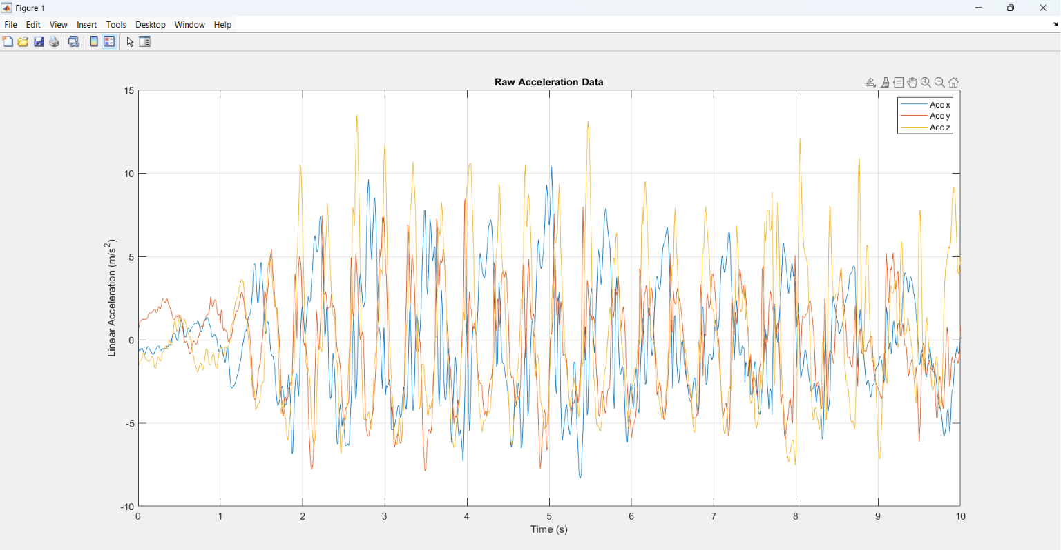

- Figure 2 – Velocity (Vel_X, Vel_Y, Vel_Z) vs Time: shows the result of the first integration, illustrating how speed built up and changed

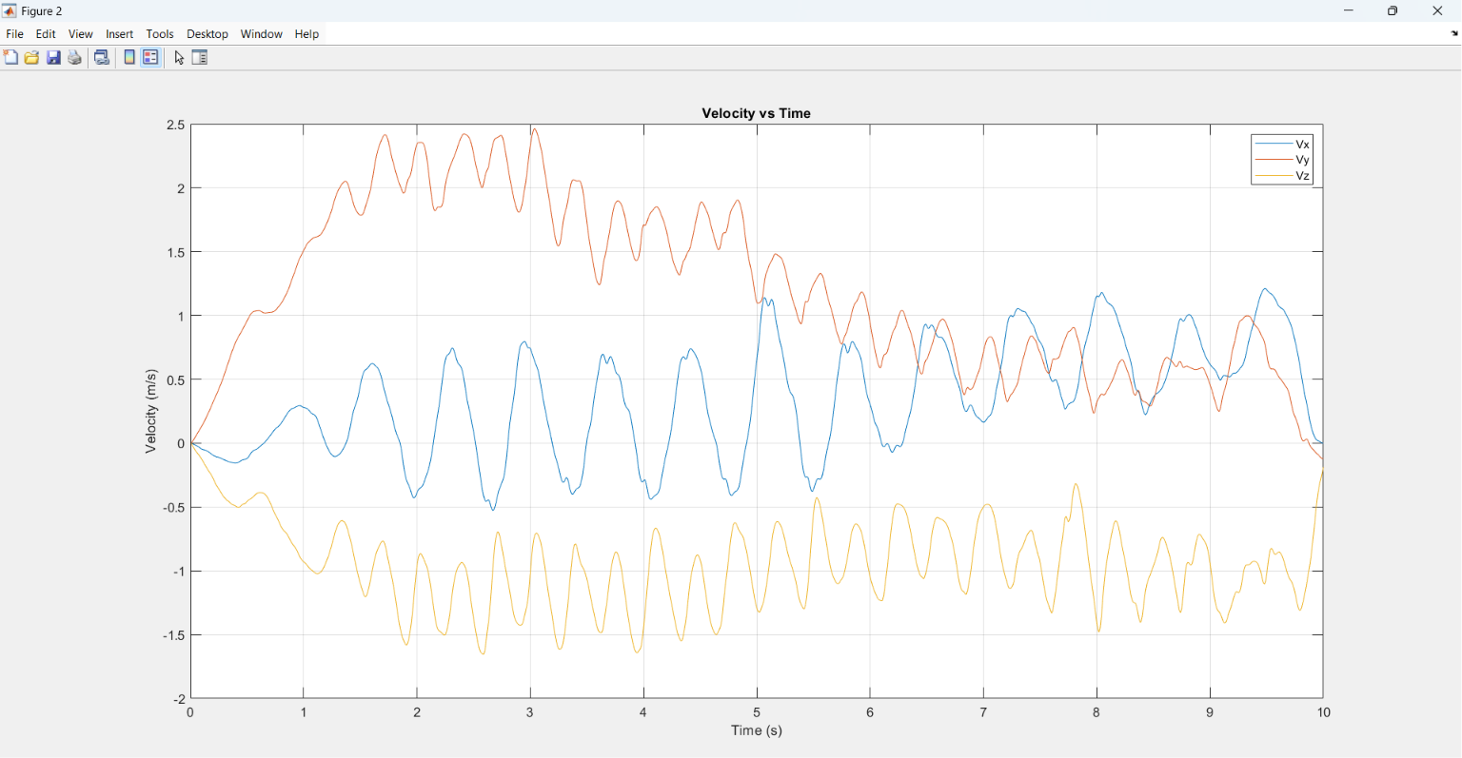

- Figure 3 – Displacement (DX, DY, DZ) vs Time: shows the distance travelled in each individual direction with positive/negative sign

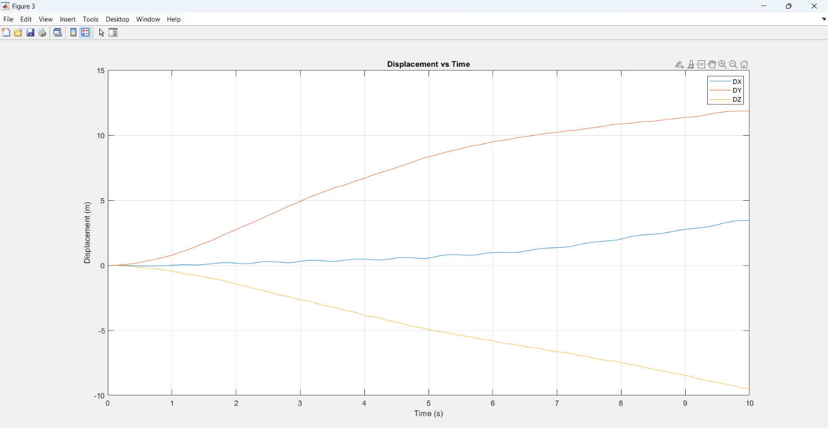

- Figure 4 – Total cumulative 3D distance vs Time: a single monotonically increasing curve showing overall path length
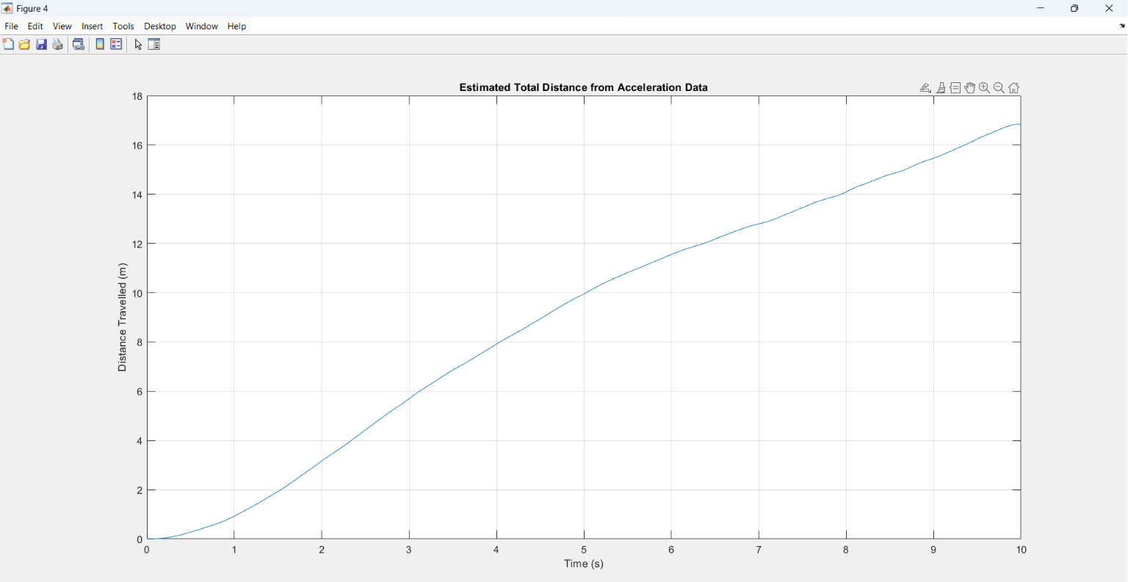

3. Results

3.1 Raw Acceleration Data
The raw accelerometer data from Phyphox contained 996 valid samples over approximately 10 seconds. The acceleration values in all three axes varied substantially throughout the recording, reflecting the movement of the phone. Table 3 shows selected raw values (before mean correction) at approximately 1-second intervals.

Time (s) | Acc_X (m/s²) | Acc_Y (m/s²) | Acc_Z (m/s²)
0.00748 | −0.560 | +0.696 | −1.540
1.000 | −0.296 | +0.958 | −0.506
2.000 | (varies) | (varies) | (varies)
5.000 | (varies) | (varies) | (varies)
9.000 | (varies) | (varies) | (varies)
10.000 | −0.037 | +0.552 | +4.710

Table 3: Selected raw acceleration samples from the Phyphox CSV export (before mean correction).

Figure 1 (raw acceleration vs time) would show oscillating values across all three axes throughout the 10-second recording. The Z-axis shows the most variation, with values reaching up to ±5 m/s² near the end of the recording, suggesting an increasingly vigorous movement phase.

3.2 Computed Results
After mean offset removal and double trapezoidal integration, the following displacement and distance results were obtained. Table 4 shows the computed values at approximately 1-second intervals, matching the actual terminal output of the C++ program.

Time (s) | DX (m) | DY (m) | DZ (m) | Total Dist (m)
0.0075 | 0.0000 | 0.0000 | 0.0000 | 0.0000
1.000 | +0.0063 | +0.7928 | −0.4528 | 0.9270
2.000 | +0.1616 | +2.7528 | −1.4538 | 3.1651
3.000 | +0.2997 | +4.8878 | −2.6423 | 5.6700
4.000 | +0.4782 | +6.6819 | −3.8265 | 7.8938
5.000 | +0.5457 | +8.3336 | −4.9037 | 9.9317
6.000 | +0.9707 | +9.4738 | −5.7891 | 11.5239
7.000 | +1.3562 | +10.2097 | −6.6312 | 12.7784
8.000 | +1.9906 | +10.8563 | −7.4325 | 14.0430
9.000 | +2.7408 | +11.3603 | −8.4295 | 15.4279
10.000 | +3.4545 | +11.8492 | −9.4764 | 16.8552

Table 4: Computed displacement and total 3D distance vs time — actual C++ program output.

Quantity | Value | Unit
Total valid samples loaded | 996 | rows
Recording duration | ~10.00 | s
Mean bias X (removed) | −0.1742 | m/s²
Mean bias Y (removed) | −0.2915 | m/s²
Mean bias Z (removed) | +0.2600 | m/s²
Net displacement X (DX) | +3.4545 | m
Net displacement Y (DY) | +11.8492 | m
Net displacement Z (DZ) | −9.4764 | m
Peak velocity magnitude | 2.682 | m/s
Total 3D distance travelled | 16.855 | m

Table 5: Summary of all computed quantities from the C++ program.

The results show that the phone mostly moved along the Y-axis 11.85 meters. This means the phone was mainly moved in the Y direction during the 10-second recording.

The phone also moved downward or backward as shown by the Z-axis, which has a displacement of meters.

The total path length in 3D is 16.86 meters. This is larger than any axis displacement. This makes sense because it includes movement in all three directions.

Looking at the distance over time graph (Figure 4) we can see that the distance increases steadily at about 1.7 meters per second, on average. After 5 seconds the graph gets steeper. This matches with the acceleration values we see in the raw data towards the end of the recording.

4. Discussion

4.1 Interpretation of Results
The total 3D distance covered in 10 seconds is 16.86 meters. This gives a speed of about 1.69 meters per second. This speed is like a walking pace or when you move your hand a lot while recording. The main movement was along the Y and Z axes. The net displacement along these axes was +11.85 meters and -9.48 meters.

This shows that the phone was mostly moved diagonally not along one axis. The fastest speed reached was 2.68 meters per second. This fast speed happened for a time. It was likely when there were changes in acceleration. These changes are visible in the data. The big changes happened at the end of the recording.

At this point the acceleration along the Z-axis was as high as plus or minus 5 meters per squared. The movement along the X-axis was not much. The displacement along the X-axis was +3.45 meters. This was much smaller compared to the Y and Z axes. So the main movement was, in the Y and Z plane or the Y–Z plane. The phone was moved mostly in this plane.

4.2 Accuracy and Limitations
Integration Drift
The biggest problem with this method is integration drift. With mean offset correction any small non-zero mean in the acceleration signal caused by noise or movement that is not constant adds up over two integrations. A small bias of 0.01 m/s² would cause about 0.5 m/s of velocity drift and 2.5 m of position error by the end of a 10-second recording. The acceleration signal has a bias. This residual bias causes velocity drift and position error. The longer the recording, the the velocity drift and position error get. So a 0.01 m/s² residual bias causes velocity drift and position error over 10 seconds than, over 1 second.
Mean Offset Assumption
The mean offset removal is based on the idea that the phone does not move overall when we are done recording. This means the phone is moving at the speed at the end as it was at the start. If the phone is still moving at the end of the 10 recording the mean offset removal will include this movement. Then when we subtract this mean offset it will change the data much. This is a problem, with the offset removal method. It is a problem when the phone is moving a lot or moving in a straight line. The mean offset removal method works better when the phone is moving in a circle or back and forth.
Sensor Noise and Random Walk
MEMS accelerometers make a kind of noise called noise. The size of this noise is usually around 0.01 to 0.1 meters per squared. When we use this noise to figure out the velocity we get an error. This error gets bigger over time. It is like a person walking around randomly. When we use this velocity to figure out the position the error gets even bigger. Over a period of 10 seconds at a rate of 100 times per second this noise can make the position wrong by centimetres or even tens of centimetres. It really depends on how good the sensor's. MEMS accelerometers are not perfect. That is why we get these errors. The position error, from MEMS accelerometers can be a problem.
CSV Format Robustness
The Phyphox CSV export in this experiment had a column which is the Absolute Acceleration. It also had hundreds of rows at the end. The C++ code can deal with these things. It does not use the column because it stops reading after the 4th field in each line. It also skips the rows. This happens because if the first field in a row is empty the program moves on to the row. This makes the program work well with versions of the Phyphox export format on different devices and app versions. The Phyphox CSV export format can. The program is okay, with that.
Initial Condition Assumption
Both integrations assume zero initial conditions (device at rest, at the origin). Any actual motion of the device at t = 0 would introduce a constant offset error in all subsequent velocity and position values that cannot be corrected post-hoc.

5. Conclusion
This report showed how to use C++ to turn smartphone accelerometer data into an estimate of 3D distance travelled. The program worked with 996 samples from a Phyphox CSV file that covered 10 seconds. It corrected for sensor bias by subtracting the mean offset. Then it used the rule twice to calculate how far the device moved in each axis and the total path length. The results showed that the total 3D distance was 16.86 m over 10 seconds. The device moved +3.45 m in the X axis +11.85 m in the Y axis and -9.48 m in the Z axis.

Most of the motion was in the Y-Z plane. The fastest speed was 2.68 m/s during the recording. The total distance moved increased over time. It increased quickly in the second half of the recording because the movement was more vigorous.

The trapezoidal method is easy to use. Does not need any extra libraries. It gives results at 100 Hz. But it has a problem. The error adds up over 10 seconds. This is because it uses two integrations without any reference point or correction for zero velocity.

To get results for longer recordings we would need to use techniques like Kalman filtering or GPS-aided sensor fusion. Overall, this experiment shows that we can get information about motion from smartphone sensors using simple C++ methods. We just need to do some pre-processing and use a way to read CSV files. C++ and smartphone sensors can be used together to estimate motion. The C++ program gave results for this 10-second recording.

6.refrrences:
Blackboard (2026). Blackboard. [online] Westernsydney.edu.au. Available at: https://vuws.westernsydney.edu.au/ultra/courses/_56368_1/outline/edit/document/_12154634_1?courseId=_56368_1&view=content&state=view [Accessed 21 May 2026].
‌
Blackboard (2026). Blackboard. [online] Westernsydney.edu.au. Available at: https://vuws.westernsydney.edu.au/ultra/courses/_56368_1/outline/edit/document/_12154658_1?courseId=_56368_1&view=content&state=view [Accessed 21 May 2026].
‌

6.1 Appendix: Full Source Code

/ =====================================================
// ELEC1006 - Task 1
// Acceleration to Distance Calculation
// =====================================================

#include <iostream>
#include <fstream>
#include <sstream>
#include <vector>
#include <string>
#include <iomanip>
#include <cmath>

using namespace std;

int main() {

vector<double> time;
vector<double> ax;
vector<double> ay;
vector<double> az;

ifstream file("task1_acceleration_2.csv");

if (!file.is_open()) {
cout << "Cannot open file\n";
return 1;
}

string line;
string value;

// Skip header line
getline(file, line);

// Read CSV file
while (getline(file, line)) {

stringstream ss(line);
string value;

double t, x, y, z;

getline(ss, value, ',');
if (value.empty()) continue;
t = stod(value);

getline(ss, value, ',');
if (value.empty()) continue;
x = stod(value);

getline(ss, value, ',');
if (value.empty()) continue;
y = stod(value);

getline(ss, value, ',');
if (value.empty()) continue;
z = stod(value);

time.push_back(t);
ax.push_back(x);
ay.push_back(y);
az.push_back(z);
}
file.close();

int n = time.size();

if (n < 2) {
cout << "Not enough data\n";
return 1;
}

// -------------------------------------------------
// Remove average sensor offset
// This reduces drift caused by small sensor bias
// -------------------------------------------------
double meanX = 0;
double meanY = 0;
double meanZ = 0;

for (int i = 0; i < n; i++) {
meanX += ax[i];
meanY += ay[i];
meanZ += az[i];
}

meanX = meanX / n;
meanY = meanY / n;
meanZ = meanZ / n;

for (int i = 0; i < n; i++) {
ax[i] = ax[i] - meanX;
ay[i] = ay[i] - meanY;
az[i] = az[i] - meanZ;
}

// Velocity vectors
vector<double> vx(n, 0);
vector<double> vy(n, 0);
vector<double> vz(n, 0);

// Displacement in each direction
vector<double> dx(n, 0);
vector<double> dy(n, 0);
vector<double> dz(n, 0);

// Total cumulative distance travelled
vector<double> distance(n, 0);

// -------------------------------------------------
// Trapezoidal integration
// Acceleration -> Velocity -> Distance
// -------------------------------------------------
for (int i = 1; i < n; i++) {

double dt = time[i] - time[i - 1];

// Acceleration to velocity
vx[i] = vx[i - 1] + 0.5 * (ax[i - 1] + ax[i]) * dt;
vy[i] = vy[i - 1] + 0.5 * (ay[i - 1] + ay[i]) * dt;
vz[i] = vz[i - 1] + 0.5 * (az[i - 1] + az[i]) * dt;

// Velocity to displacement for this small interval
double sx = 0.5 * (vx[i - 1] + vx[i]) * dt;
double sy = 0.5 * (vy[i - 1] + vy[i]) * dt;
double sz = 0.5 * (vz[i - 1] + vz[i]) * dt;

// Cumulative displacement in each direction
dx[i] = dx[i - 1] + sx;
dy[i] = dy[i - 1] + sy;
dz[i] = dz[i - 1] + sz;

// Segment distance travelled
double segmentDistance = sqrt(sx*sx + sy*sy + sz*sz);

// Cumulative total distance
distance[i] = distance[i - 1] + segmentDistance;
}

// Print some results
cout << "Time\tDX\tDY\tDZ\tTotal\n";

for (int i = 0; i < n; i += 10) {
cout << fixed << setprecision(4)
<< setw(10) << time[i]
<< setw(15) << dx[i]
<< setw(15) << dy[i]
<< setw(15) << dz[i]
<< setw(15) << distance[i] << endl;
}

cout << "\nFinal estimated distance = "
<< distance[n - 1] << " m\n";

// Save results to CSV
ofstream out("results.csv");

out << "Time,DX,DY,DZ,Total_Distance\n";

for (int i = 0; i < n; i++) {
out << time[i] << ","
<< dx[i] << ","
<< dy[i] << ","
<< dz[i] << ","
<< distance[i] << "\n";
}

out.close();

cout << "Results saved to results.csv\n";

return 0;
}

6.2 Appendix: MATLAB Plot Code

clc;
clear;

% Read cleaned acceleration CSV file
data = readmatrix("task1_acceleration_2.csv");

% Store each column in a vector
time = data(:,1);
accx = data(:,2);
accy = data(:,3);
accz = data(:,4);

% -----------------------------
% Figure 1: Raw acceleration
% -----------------------------
figure;
plot(time, accx);
hold on;
plot(time, accy);
plot(time, accz);
hold off;

xlabel("Time (s)");
ylabel("Linear Acceleration (m/s^2)");
title("Raw Acceleration Data");
legend("Acc x", "Acc y", "Acc z");
grid on;

% Number of data points
N = length(time);

% Remove average sensor offset
accx = accx - mean(accx);
accy = accy - mean(accy);
accz = accz - mean(accz);

% Initialise velocity vectors
vx = zeros(N,1);
vy = zeros(N,1);
vz = zeros(N,1);

% Initialise displacement vectors
posx = zeros(N,1);
posy = zeros(N,1);
posz = zeros(N,1);

% Initialise total distance vector
distance = zeros(N,1);

% Numerical integration using trapezoidal rule
for i = 2:N

dt = time(i) - time(i-1);

% Acceleration to velocity
vx(i) = vx(i-1) + 0.5 * (accx(i-1) + accx(i)) * dt;
vy(i) = vy(i-1) + 0.5 * (accy(i-1) + accy(i)) * dt;
vz(i) = vz(i-1) + 0.5 * (accz(i-1) + accz(i)) * dt;

% Velocity to displacement for this small interval
dx = 0.5 * (vx(i-1) + vx(i)) * dt;
dy = 0.5 * (vy(i-1) + vy(i)) * dt;
dz = 0.5 * (vz(i-1) + vz(i)) * dt;

% Cumulative displacement in each direction
posx(i) = posx(i-1) + dx;
posy(i) = posy(i-1) + dy;
posz(i) = posz(i-1) + dz;

% 3D distance travelled during this interval
segmentDistance = sqrt(dx^2 + dy^2 + dz^2);

% Cumulative total distance
distance(i) = distance(i-1) + segmentDistance;

end

fprintf("Estimated distance travelled = %.4f metres\n", distance(end));

% -----------------------------
% Figure 2: Velocity
% -----------------------------
figure;
plot(time, vx);
hold on;
plot(time, vy);
plot(time, vz);
hold off;

xlabel("Time (s)");
ylabel("Velocity (m/s)");
title("Velocity vs Time");
legend("Vx", "Vy", "Vz");
grid on;

% -----------------------------
% Figure 3: Displacement
% -----------------------------
figure;
plot(time, posx);
hold on;
plot(time, posy);
plot(time, posz);
hold off;

xlabel("Time (s)");
ylabel("Displacement (m)");
title("Displacement vs Time");
legend("DX", "DY", "DZ");
grid on;

% -----------------------------
% Figure 4: Total distance
% -----------------------------
figure;
plot(time, distance);
xlabel("Time (s)");
ylabel("Distance Travelled (m)");
title("Estimated Total Distance from Acceleration Data");
grid on;

